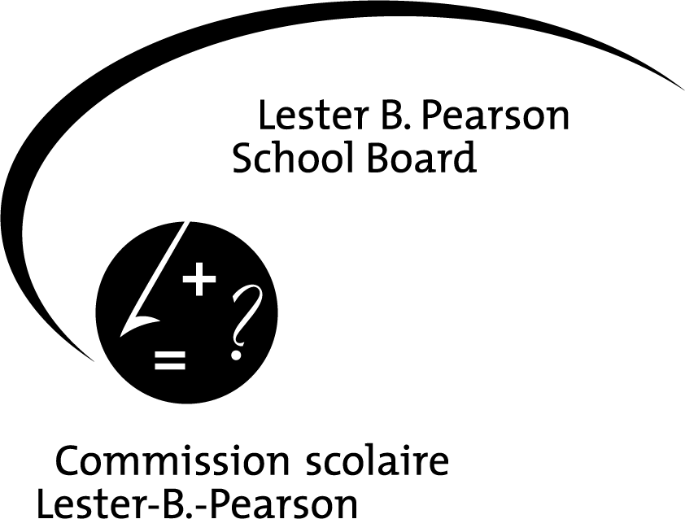

ADDENDUM D

Emergency Medical Treatment Form

SCHOOL:

Beaconsfield High School
STUDENT’S NAME: GRADE LEVEL:

STUDENT’S QUÉBEC HEALTH INSURANCE NO. : |  | EXPIRY DATE:
MEDICAL ALERTS, ALLERGIES, ETC. (SPECIFY TYPE):

IF MEDICATION HAS BEEN PRESCRIBED, PLEASE SPECIFY TYPE:

- If the student is using prescribed medication for asthma and/or allergies, he/she must carry this medication on his/her person at all times. Failure to do so will result in the student being disallowed from participating in this event.
- You are responsible for submitting a revised form if there any changes in the medical information you are providing.

NAME OF FAMILY PHYSICIAN (IF AVAILABLE):

EMERGENCY MEDICAL TREATMENT

The undersigned hereby agrees that, in the event that I or my spouse or parent/tutor/guardian cannot be contacted within a reasonable period of time, the person in charge be appointed to authorize the admission to hospital, if deemed necessary by a medical doctor, and emergency medical treatment recommended by a medical doctor be given to the above named student while participating in this activity, trip and related events.

NAME OF PARENT, TUTOR OR LEGAL GUARDIAN(s): _______________________________________________________________________

HOME ADDRESS: _____________________________________________________________________________________________________

HOME TELEPHONE #: _____________________________________ ALTERNATE TELEPHONE #: ___________________________
Neighbour or Relative

BUSINESS TELEPHONE #: ______________________________ _______________________________________
Father Mother

CELL #: _________________________________ ___________________________________

GUARDIAN: Home # ________________________________________ Cell #: ____________________________

MOTHER’S MAIDEN NAME: _____________________________________________________________________________________

_____________________________________________ __________________________________________
Signature and Relationship Date

This form must be completed for all types of trips or activities off school premises

