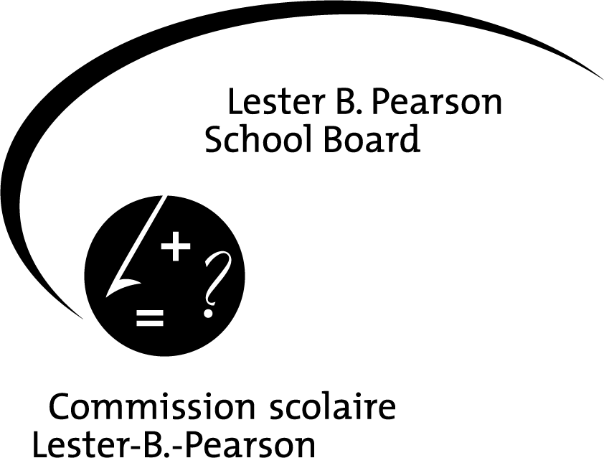

ADDENDUM E

Permission and Release Form

SCHOOL:

Beaconsfield High School
EDUCATIONAL OBJECTIVE:

To attend a Montreal Symphony Orchestra performance
THEME OF EVENT:

A New World
DESTINATION:

Place des Arts, Montréal
DATE:

February 13th 2013, from 9 am until 12 pm
METHOD OF TRANSPORTATION:

School bus
5
SUPERVISION: COST:
70
1 :15
$26

ADULTS STUDENTS ADULT/STUDENT RATIO COST PER STUDENT

PERSON(S) IN CHARGE: Phil Legault and Valérie Lepage
AND
OTHER ADULTS: __________________________________________________________________________________________

PERMISSION & RELEASE

NAME OF STUDENT: ______________________________________________________________ GRADE LEVEL:_____________

- The undersigned declares that the above named student is a minor in their legal charge.
- The undersigned acknowledges full awareness of the risks involved in this trip, and accepts the arrangements for supervision as noted above; consequently, the undersigned hereby grants permission for the above named student to participate in this activity.
- A signed Emergency Medical Treatment Form is on file. Please submit a revised form to reflect any changes.
4. If necessary, the undersigned authorizes the student to be carpooled.

NAME OF ADULT STUDENT, PARENT, TUTOR OR LEGAL GUARDIAN (PLEASE PRINT): __________________________________

______________________________________________________ __________________________________________________
Signature Date

This form must be completed for all types of trips or activities off school premises

v

