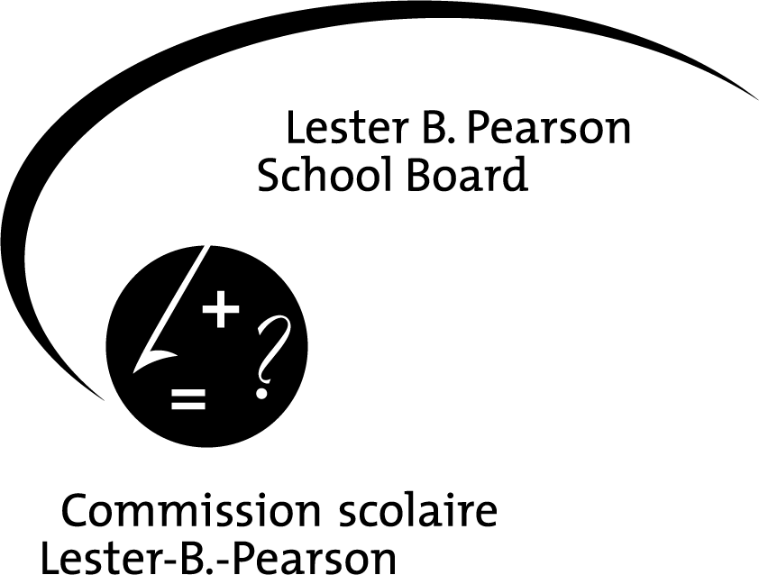

ADDENDUM E

Permission and Release Form

SCHOOL:

Beaconsfield High School
EDUCATIONAL OBJECTIVE:

To perform in a music festival
THEME OF EVENT:

Boston Heritage Music Festival
DESTINATION:

Boston, Massachusetts, USA
DATE:

FROM: April 18th 2013 TO:April 21st 2013
METHOD OF TRANSPORTATION:

Coach Buses
5
SUPERVISION: COST:
75
1 :15
$750

ADULTS STUDENTS ADULT/STUDENT RATIO COST PER STUDENT

PERSON(S) IN CHARGE: Phil Legault and Valérie Lepage________________________________________________________________
AND
OTHER ADULTS: __________________________________________________________________________________________

PERMISSION & RELEASE

NAME OF STUDENT: ______________________________________________________________ GRADE LEVEL:_____________

- The undersigned declares that the above named student is a minor in their legal charge.
- The undersigned acknowledges full awareness of the risks involved in this trip, and accepts the arrangements for supervision as noted above; consequently, the undersigned hereby grants permission for the above named student to participate in this activity.
- A signed Emergency Medical Treatment Form is on file. Please submit a revised form to reflect any changes.
4. If necessary, the undersigned authorizes the student to be carpooled.

NAME OF ADULT STUDENT, PARENT, TUTOR OR LEGAL GUARDIAN (PLEASE PRINT): __________________________________

______________________________________________________ __________________________________________________
Signature Date

This form must be completed for all types of trips or activities off school premises

v

